Project Design Phase
AI FitTrack – Proposed Solution Template
Date | 24 September 2026
Team ID | SWTID-2026-9501
Project Name | AI FitTrack – AI-Powered Fitness Tracking System
Maximum Marks | 2 Marks
Proposed Solution Template:
Project team shall fill the following information in the proposed solution template.
S.No. | Parameter | Description
 | Problem Statement (Problem to be solved) | Fitness users need a secure, centralized way to track workouts, review progress and receive personalized guidance without manually combining multiple tools.
 | Idea / Solution description | A React web client backed by a JWT-secured Express REST API, MongoDB Atlas persistence, dashboard analytics and Gemini-powered fitness recommendations and insights.
 | Novelty / Uniqueness | Combines workout CRUD, analytics and AI guidance in one modular full-stack application while keeping AI isolated behind a service layer.
 | Social Impact / Customer Satisfaction | Encourages consistent activity tracking, clearer progress awareness and personalized suggestions while presenting information in an accessible web interface.
 | Business Model (Revenue Model) | Potential future freemium model: core tracking free, premium AI coaching, advanced analytics and integrations as optional paid capabilities.
 | Scalability of the Solution | React and API layers can be deployed independently; MongoDB Atlas supports managed database growth; additional services can be added without changing core workout routes.
Modern Product Positioning
AI FitTrack is designed as a modular fitness platform rather than a single-purpose workout form. The product separates identity, workout history, analytics and AI coaching so each capability can evolve independently.
• Primary user: fitness user who wants simple tracking and progress visibility.
• Core value: structured workout history plus immediate analytics.
• AI value: personalized recommendations and insights when provider access is available.
• Trust value: authenticated access and user-scoped workout data.
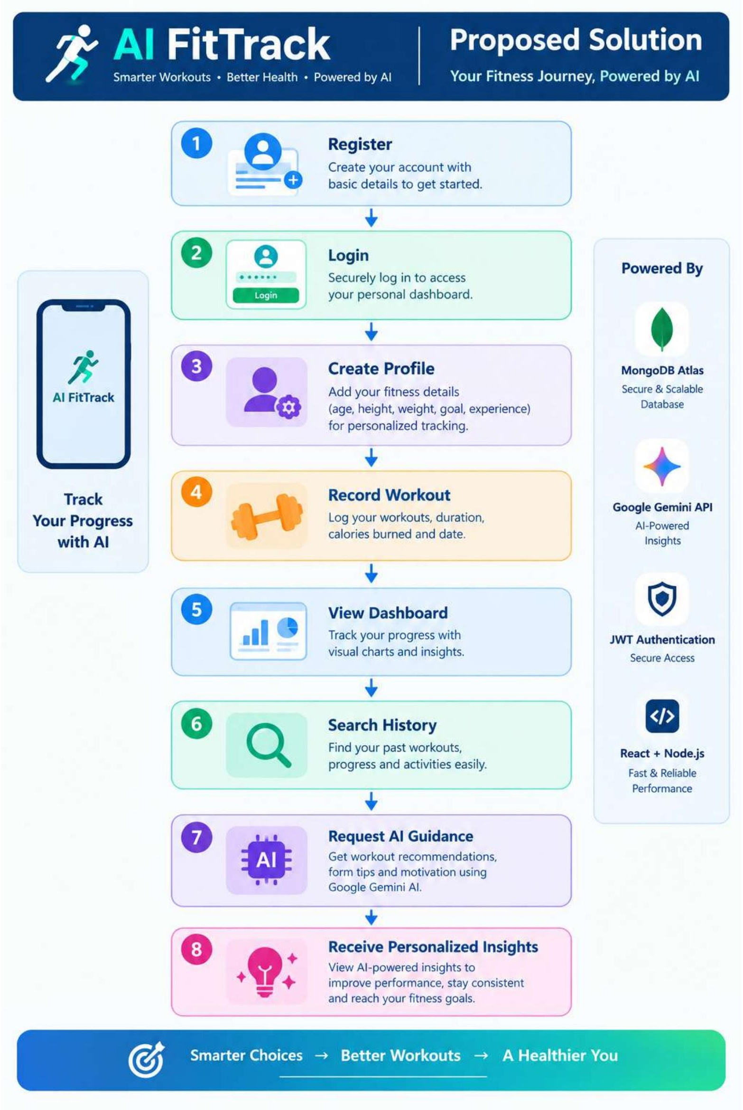
Solution Success Measures
• User can complete registration and login without exposing passwords.
• Workout can be created, searched, updated and deleted.
• Dashboard provides consistent totals from stored workout records.
• React client and REST API remain usable independently.
• AI requests produce useful responses when Gemini generation access is enabled.

